Connection string problems.

Fixed by deleting connection string in WebServer, then having the system create connection string in database connection during publish, then export, See following blog
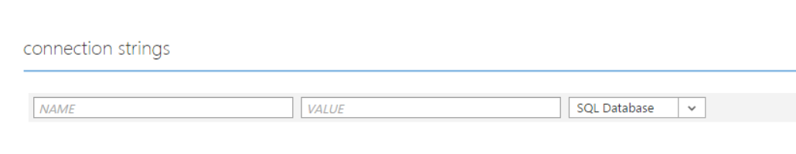
to be empty!!!!

http://stackoverflow.com/questions/13840326/entity-framework-work-locally-but-not-on-azure/15858768

I was having this exact problem today; it's my first time deploying to Azure. I've been pulling my hair out, except I don't have any left. I finally figured it out, and it's probably the same issue original poster here is having.
Just like the original poster, I tested in these configurations:
- ran WCF Web App from Visual Studio against local DB -- success
- deployed WCF Web App from Visual Studio to local IIS, ran against local DB -- success
- ran WCF Web App from Visual Studio against Azure SQL DB -- success
- deployed WCF App to Azure via Visual Studio, running against Azure SQL DB -- FAILURE!!
After reading another post (Code First vs. Database First) I got a hint. That post says that if "connection string has the metadata, EF thinks it is Model First or Database First" but if it's a "plain connection string, EF thinks it is Code First." I browsed the deployed Azure Web Site's web.config and confirmed that the connection string had the proper references to the Model-First metadata. So what was the problem???
I figured that perhaps the Azure Website wasn't reading the web.config's connection string. Thinking back to how I'd created the Azure Web Site, I remembered that I'd given the Azure SQL DB an alias with the exact same name as my connection string's 'label' in the web.config!! To clarify:
- in the Azure admin console I went to the Website settings and reviewed the "connection string" settings "baked in" to my Azure web site as a side-effect of creating-website-with-DB -- connection string 'handle' was "SsnCustInfoModelContainer" -- I'd mistakenly given the connection the same 'handle'/'alias' as my web.config 'handle' for the connection string, thinking this would help. Instead, when EF looks for the connection string, it was finding this 'aliased' handle, which was a "plain" SQL connection string containing no metadata. This 'alias' masked the real connection string specified in the web.config.
So I destroyed my Azure SQL DB and my Azure Web Site. Then I recreated the Azure Web Site, but this time I asked for the connection string 'alias' of "SsnCustInfoModelContainer_Proto" for the connection to the associated Azure SQL Server. After initializing the Azure SQL DB from my local SQL Server Management Studio, I deployed the WCF web app again to the Azure Web Site (I had to download a new deployment profile, of course, to do this), I tried the app again. This time it worked -- the 'alias' "SsnCustInfoModelContainer_Proto" did not conflict with and was not found by EF. EF instead went on to find the true connection string, with all the proper metadata, in the web.config.Problem solved.

